Argha Das
24341220
CSE421 Section13
Spring 26

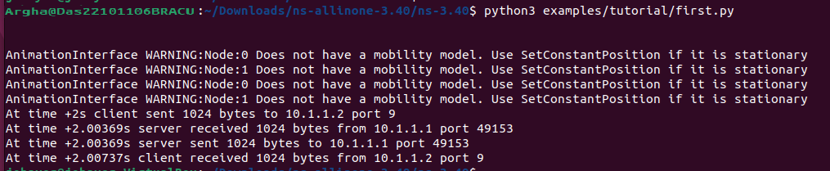
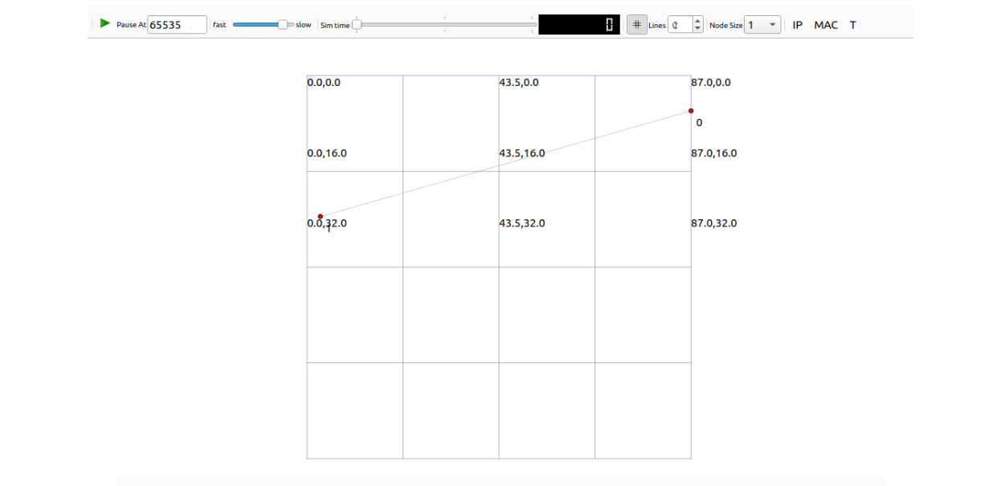
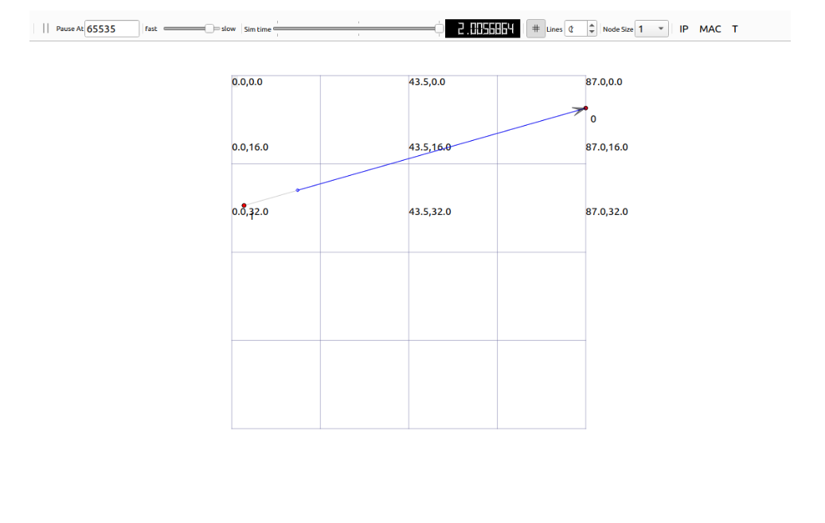

128:
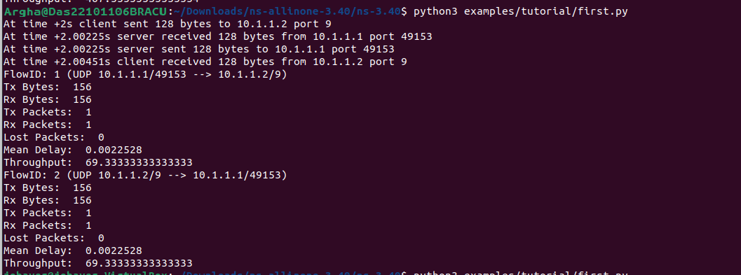

256: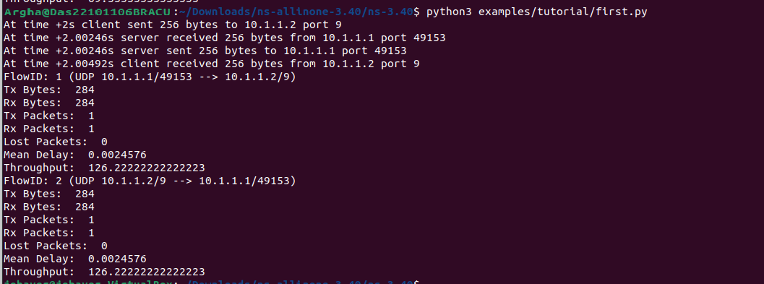

512: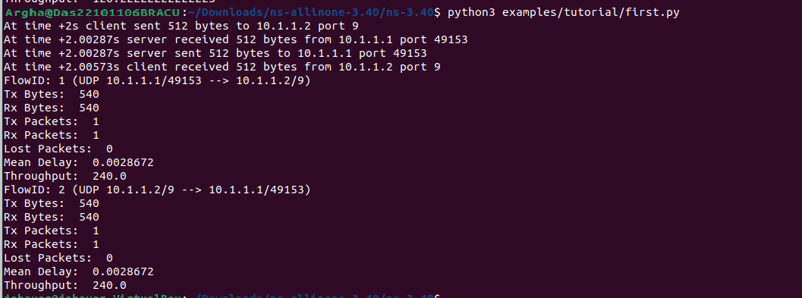

1024: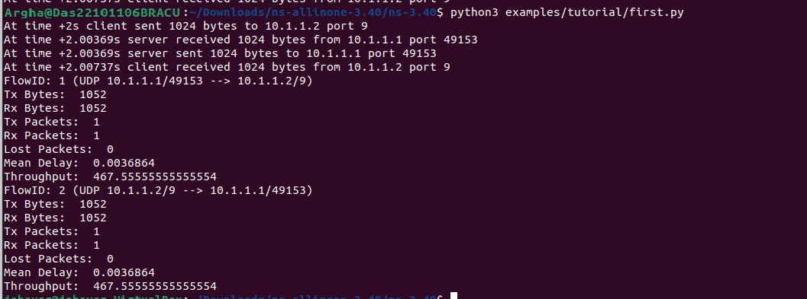

2024:
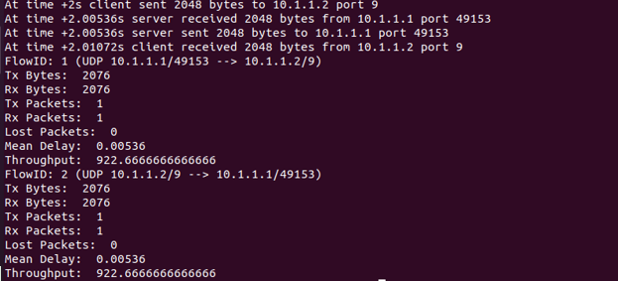

Graph:
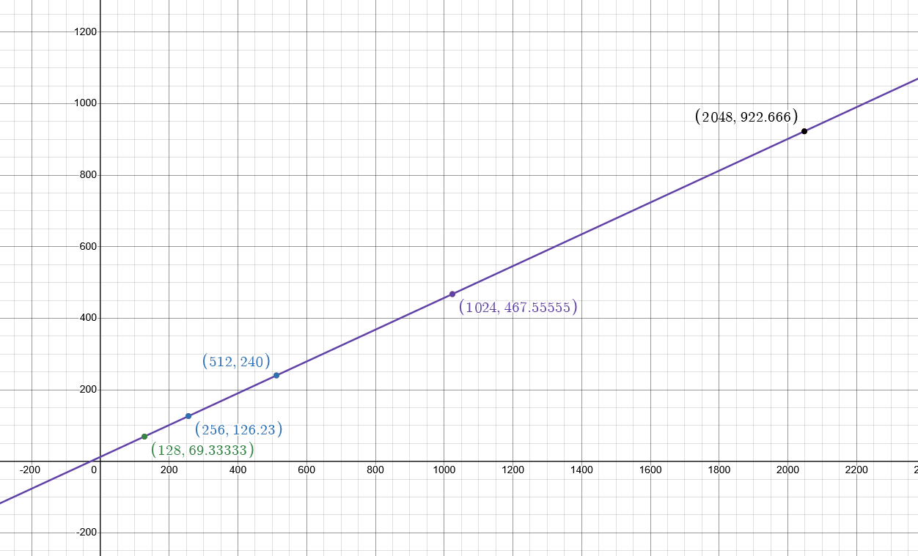
Figure: Packet Data Size vs Throughput

Here, the X-axis is the Packet Data Size, ranging from 128 to 2048. The Y-axis is the Throughput. The graph shows that the line is upward. The packet data sizes are 128, 256, 512, 1024, 2048, and the throughput values are 69.33333333333333,126.22222222222223, 240.0, 467.55555555555554. 922.6666666666666. It clearly shows that if the packet size increases, the throughput value also increases.

